Consciously Parenting

& About Connections

with Rebecca Thompson

Ray Castellino and Mary Jackson

are thrilled to present

a 4 part audio series web-seminar on

Infant and Toddler Sleep

You are invited to go to :

http://www.consciouslyparenting.com/ondemand/LPBC/sleep/

to find out how you can hear this program.

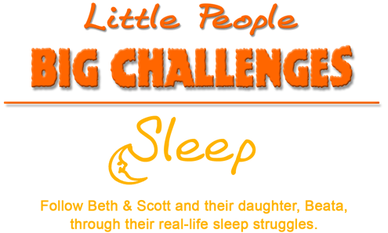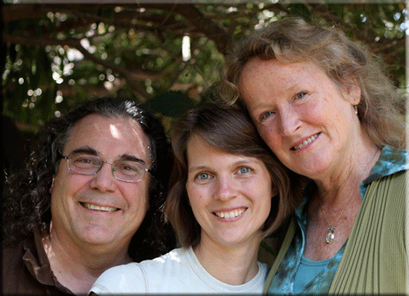
Ray, Rebecca and Mary, July 2010

